

AMERICAN INTERNATIONAL UNIVERSITY–BANGLADESH (AIUB)
Dept. of Computer Science
Faculty of Science and Technology
CSC2210: OBJECT ORIENTED PROGRAMMING 2
Summer 2025-2026
Section: [O]

Project Report On
Project Name [ECOCOMMUTE TRACKER MANAGEMENT SYSTEM ]
Supervised By
Al Jubair Hossain

Submitted By:
Name | ID
1.MAHINUL ISLAM | 24-60426-3
2.MOSTAFA SHAMIL | 24-58516-2
3. KAZI ZISHAN AHMED | 24-58687-2
4. MD. JAHID HASAN | 24-57948-2
Obtained Marks for CO2 and CO4 (Description given in the following page)
Assessment  Criteria | Not Attended/ Incorrect (0) |  | Inadequate  (1-2) |  | Average  (3) | Good  (4) | Excellent  (5)
Evaluation Criteria (CO2) |  | Total = |  | Evaluation Criteria (CO4) |  |  | Total =
Requirement fulfillment |  |  |  | Design & Innovation
Validation |  |  |  | Teamwork & Ethics
Verification |  |  |  | Communication

CO2: Display and verify the mean of a real-life Project using the concepts of C# Graphical User Interface based environment with database integration to depict a desktop-based application.
Assessment  Criteria | Not Attended/ Incorrect (0) | Inadequate  (1-2) |  | Average  (3) |  | Good  (4) |  | Excellent  (5)
Evaluation Criteria | Evaluation Definition
Requirement fulfillment | Fails to demonstrate any understanding of real-life scenario-based project development or functional requirement identification. There is no attempt to depict a project or identify functional requirements accurately. |  | Demonstrates limited understanding of real-life scenario-based project development and functional requirement identification. The project depicted lacks coherence or relevance to real-life scenarios, and functional requirements are inaccurately identified or insufficiently described. |  | Presents a basic depiction of a real-life scenario-based project and identifies some functional requirements. However, the project lacks depth or complexity, and some functional requirements may be vaguely defined or missing key details. |  | Effectively demonstrates a realistic scenario-based project and accurately identifies most functional requirements. The project is well-developed with appropriate complexity, and functional requirements are clearly articulated with relevant details. |  | Exhibits an exceptional understanding of real-life scenario-based project development and accurately identifies all functional requirements. The project is meticulously developed with thorough attention to detail, reflecting a comprehensive understanding of Object-Oriented Programming project development activities.
Validation | Fails to demonstrate any understanding or implementation of validation forms in their system. There is no attempt to deal with data validation, and validation requirements are completely ignored or incorrectly applied. |  | Demonstrates limited understanding of validation forms and data validation techniques. While some attempt may be made to implement validation, it is incomplete or poorly executed, leading to inadequate handling of data validation. |  | Shows a basic understanding of validation forms and data validation techniques. They attempt to implement validation, but some aspects may be missing or incorrectly implemented, resulting in partial or inconsistent handling of data validation. |  | Effectively demonstrates the use of validation forms and implements data validation techniques. Validation is mostly accurate and comprehensive, ensuring the proper handling of data input and verification in the system. |  | Exhibits an exceptional understanding and implementation of validation forms and data validation techniques. Validation is meticulously implemented with thorough attention to detail, ensuring robust data validation procedures and contributing to the overall reliability and integrity of the system.
Verification | Fails to demonstrate any attempt to verify the system data or functional requirements. There is no evidence of understanding or implementation of verification processes, and data flow is not considered. |  | Demonstrates limited understanding of verification processes and data flow in the system. Verification attempts are incomplete or inaccurate, and there is insufficient consideration given to ensuring data integrity and functionality. |  | Shows a basic understanding of verification processes and attempts to verify system data. However, verification efforts may be inconsistent or lack thoroughness, and there may be gaps in ensuring proper functional requirements and data flow. |  | Identifies and verifies system data, ensuring proper functional requirements are met. Verification efforts are mostly accurate and thorough, with attention to ensuring data integrity and appropriate data flow within the system. |  | Exhibits an exceptional understanding of verification processes and meticulously verifies system data. Verification efforts are comprehensive and precise, with a keen focus on ensuring all functional requirements are met and maintaining proper data flow throughout the system.

CO4: Display and verify the mean of a real-life Project using the concepts of C# Graphical User Interface based environment with database integration to depict a desktop-based application.
Assessment  Criteria | Not Attended/ Incorrect (0) | Inadequate  (1-2) |  | Average  (3) |  | Good  (4) |  | Excellent  (5)
Evaluation Criteria | Evaluation Definition
Requirement fulfillment | Fails to demonstrate any attempt to perform or solve system functional requirements. There is no evidence of addressing real-life scenario-based projects or identifying functional requirements for Object-Oriented Programming project development activities. |  | Demonstrates limited understanding of system functional requirements and real-life scenario-based projects. Attempts to perform or solve functional requirements may be incomplete or inaccurately applied, and there is insufficient consideration given to proper identification of requirements. |  | Shows a basic understanding of system functional requirements and attempts to perform or solve them. However, the execution may lack depth or thoroughness, and there may be gaps in addressing all aspects of real-life scenario-based projects or properly identifying functional requirements. |  | Effectively demonstrates the performance and solution of system functional requirements for real-life scenario-based projects. Requirements are identified with clarity and relevance, and the execution is mostly accurate and comprehensive, reflecting a solid understanding of Object-Oriented Programming project development activities. |  | Exhibits an exceptional understanding of system functional requirements and adeptly performs and solves them for real-life scenario-based projects. Requirements are meticulously identified and executed with thorough attention to detail, showcasing a comprehensive mastery of Object-Oriented Programming project development activities.
Validation | Fails to demonstrate any understanding or implementation of validation forms or data validation techniques. There is no evidence of addressing validation requirements or dealing with data validation in their system. |  | Demonstrates limited understanding of validation forms and data validation techniques. While some attempt may be made to implement validation, it is incomplete or poorly executed, leading to inadequate handling of data validation. |  | Shows a basic understanding of validation forms and data validation techniques. They attempt to implement validation, but some aspects may be missing or incorrectly implemented, resulting in partial or inconsistent handling of data validation. |  | Demonstrates the use of validation forms and implements data validation techniques. Validation is mostly accurate and comprehensive, ensuring the proper handling of data input and verification in the system, although there may be minor issues. |  | Exhibits an exceptional understanding and implementation of validation forms and data validation techniques. Validation is meticulously implemented with thorough attention to detail, ensuring robust data validation procedures and contributing to the overall reliability and integrity of the system.
Verification | Fails to demonstrate any understanding or attempt to verify system data or functional requirements. There is no evidence of addressing verification requirements or considering data flow in their system solution. |  | Demonstrates limited understanding of verification processes and data flow in the system. Verification attempts may be incomplete or inaccurately applied, and there is insufficient consideration given to ensuring proper functional requirements and data flow. |  | Shows a basic understanding of verification processes and attempts to verify system data. However, verification efforts may lack thoroughness or precision, and there may be gaps in ensuring proper functional requirements and data flow within the system. |  | Effectively identifies and verifies system data, ensuring proper functional requirements are met. Verification efforts are mostly accurate and comprehensive, with attention to ensuring data integrity and appropriate data flow within the system. |  | Exhibits an exceptional understanding of verification processes and meticulously verifies system data. Verification efforts are comprehensive and precise, with a keen focus on ensuring all functional requirements are met and maintaining proper data flow throughout the system.

Table of Contents: Page no.

1. Chapter: 01 (Introduction)----------------------------------------------------------------------- 07
2. Chapter: 02 (User Story)------------------------------------------------------------------------- 08
3. Chapter: 03a (ER Diagram)---------------------------------------------------------------------- 08
4. Chapter: 03b (SQL Queries)--------------------------------------------------------------------- 09
5. Chapter: 04 (Screenshots)------------------------------------------------------------------------ 10

Introduction :
The EcoCommute Tracker is a desktop application created with C# Windows Forms and integrated with a SQL Server Management Studio (SSMS) database. It helps users monitor their daily eco-commutes, calculate carbon dioxide emissions ($CO_2$) savings and store data in a structured form.Needing to isolate data securely and have control, the system utilizes Role Based Access Control (RBAC) that includes two major types of users: Regular User and System Administrator.Regular Users can log daily commuting trips, calculate current carbon emissions offset according to the distance and mode of transportation, filter historic logs using date range and export reports to the standardized .csv file format with the help of Microsoft Excel using standard File I/O classes (System.IO).System Administrators get platform-wide overview of the system and can see how many registered users there are, what are overall carbon emissions savings of the system and how accounts are stored with the ability to conduct full Create, Read, Update, Delete (CRUD) operations.Application’s data storage model is based on a relational database model with the help of entities like Users and CarbonSavings. Primary key and foreign key constraints guarantee entity and referential integrity, and parameterized SQL queries protect from any SQL injections.

User stories :

User 1: Regular User

•The Regular User portal allows individual users to record their daily commuting habits, keep track of their total carbon savings, and export their historical logs.
• Record your daily commute: enter the distance of your trip in kilometres and choose the mode of transport to have the carbon savings calculated automatically.
•To view your Personal Summary: you can keep an eye on the total amount of carbon offset accumulated, as this figure is shown in real time on the dashboard.
• Filter the Commute History by selecting specific start and end dates to query your personal activity logs.
• You can download your personal commute records as an external .csv file by using the Export CSV Report function.

User 2: System Administrator
•The portal for the System Administrator includes tools for monitoring the platform at a high level and for managing users.
•Review the system's summary metrics regarding the total number of active users and the amount of CO2 savings achieved across the entire platform.
• You can view all the registered accounts together with their individual totals of carbon savings.
• To delete an account record: choose a user from the data grid and remove both their account and their associated activity history from the database.

ER Diagram :

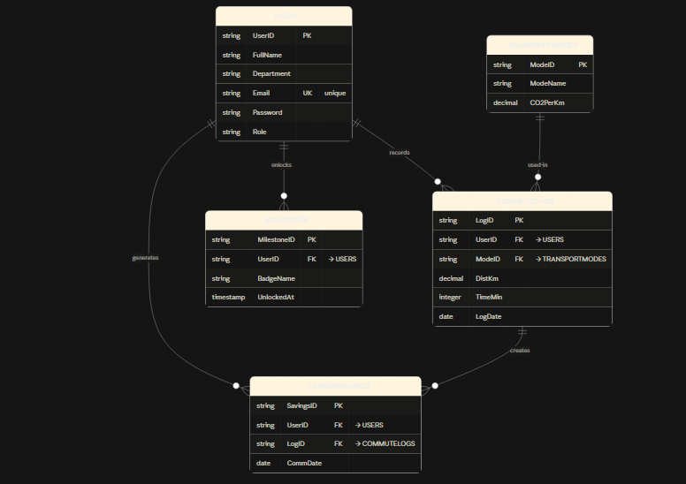

SQL Queries :

Database creation :

CREATE DATABASE EcoCommuteDB;
GO
USE EcoCommuteDB;
GO

CREATE TABLE Users (
UserID INT IDENTITY(1,1) PRIMARY KEY,
FullName VARCHAR(100) NOT NULL,
Department VARCHAR(50) NOT NULL,
Email VARCHAR(100) NOT NULL UNIQUE,
Password VARCHAR(50) NOT NULL,
Role VARCHAR(20) NOT NULL DEFAULT 'User'
);
CREATE TABLE TransportModes (
ModeID INT IDENTITY(1,1) PRIMARY KEY,
ModeName VARCHAR(50) NOT NULL,
CO2PerKm FLOAT NOT NULL
);

CREATE TABLE CommuteLogs (
LogID INT IDENTITY(1,1) PRIMARY KEY,
UserID INT NULL,
ModeID INT NULL,
DistanceKm FLOAT NOT NULL,
TravelTimeMinutes INT NOT NULL,
LogDate DATE NULL DEFAULT GETDATE(),
FOREIGN KEY (UserID) REFERENCES Users(UserID),
FOREIGN KEY (ModeID) REFERENCES TransportModes(ModeID)
);

CREATE TABLE CarbonSavings (
SavingsID INT IDENTITY(1,1) PRIMARY KEY,
UserID INT NULL,
TransportMode VARCHAR(50) NULL,
DistanceKm FLOAT NULL,
CO2SavedKg FLOAT NULL,
CommuteDate DATETIME NULL DEFAULT GETDATE(),
LogDate DATETIME NULL DEFAULT GETDATE(),
FOREIGN KEY (UserID) REFERENCES Users(UserID)
);

CREATE TABLE Milestones (
MilestoneID INT IDENTITY(1,1) PRIMARY KEY,
UserID INT NULL,
BadgeName VARCHAR(100) NOT NULL,
UnlockedAt DATETIME NULL DEFAULT GETDATE(),
FOREIGN KEY (UserID) REFERENCES Users(UserID)
);
GO

Screenshots :

Registerform :
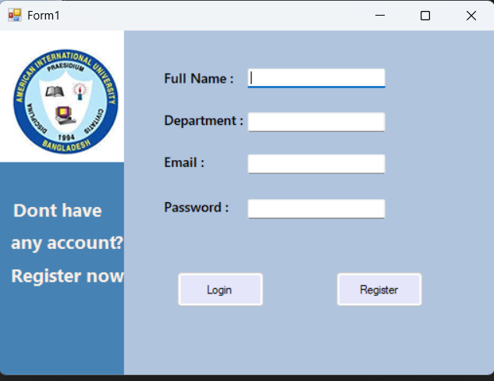

Login:

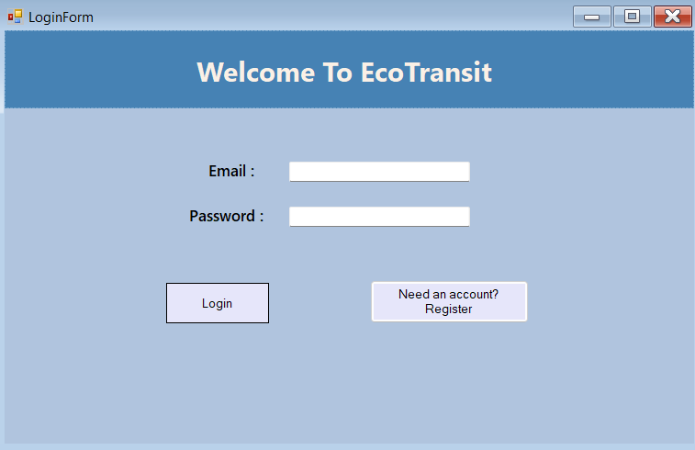

Userdashboard :
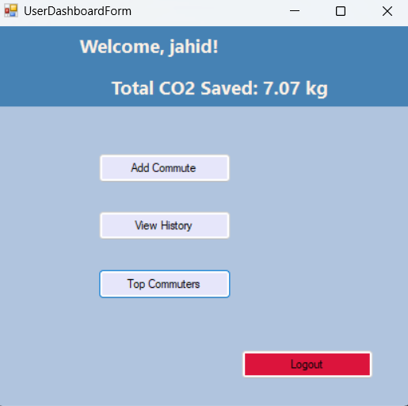

Userleaderboard :

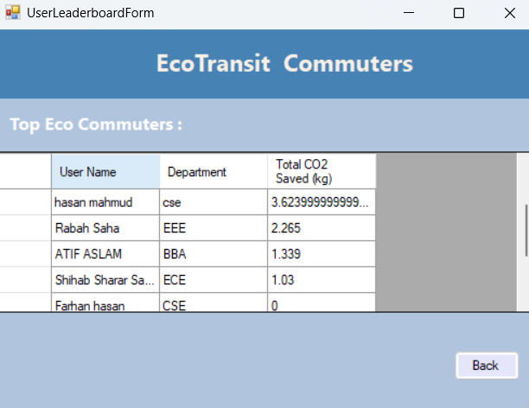

Logcommute :

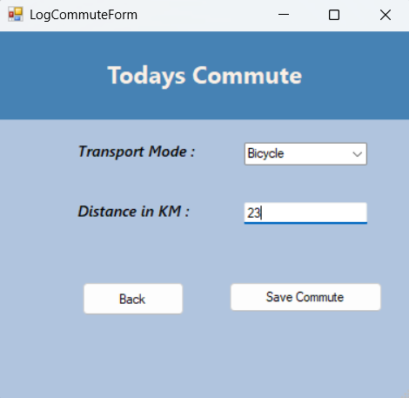

Commutehistory :

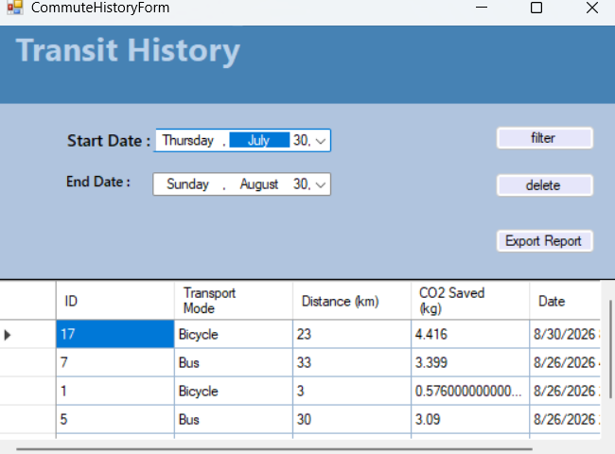

Admindashboard :

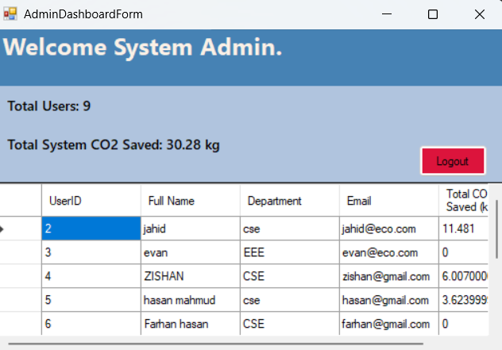
Conclusion :

The EcoCommute Tracker Management System is a working demonstration of a real-time desktop application developed in C# Windows Forms with SQL Server database integration. The system gives the normal users the ability to record their daily commute, calculate the CO2 savings, access their history and export their records. It also gives the administrators the ability to monitor users and system data.

The project also incorporates important concepts of Object Oriented Programming, database management, role based access control, CRUD operations, data validation and secure parameterized SQL queries. In general, the system offers a well-organized and user-friendly approach to monitoring environmentally friendly transportation and motivating users to minimize their carbon footprint.

